1. In the body colour design stage of all jacket applets you have not included dark oxford (dark grey)
2. The writing on the left and right arm design stage is small. It never use to be like this; it use to be bigger. We asked for the writing on the arm to start of big and decrease as more characters were added on the arm.

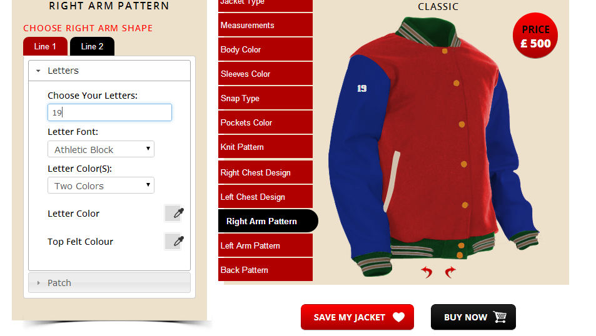

1. The inner tail text is not in the tail. It is underneath the tail patch. Also The colour boxes do not change colour even though colour have been selected. Furthermore the outline around the script with tail patch is meant to be red (that is what I selected) but you cannot see it.

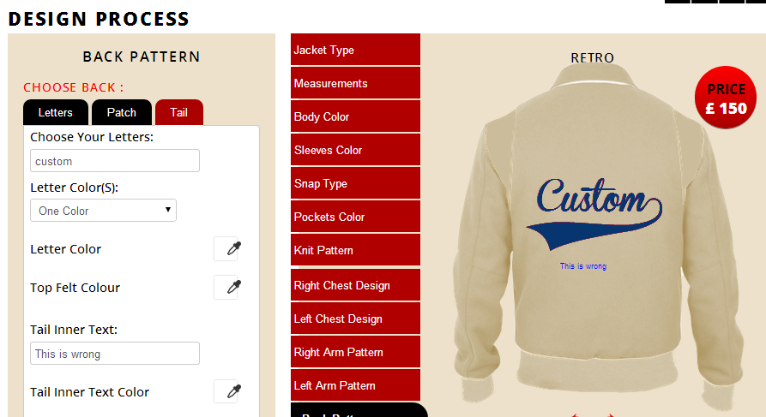

1. I asked for the 3 colour lettering option but you have yet to install that into any part of the aplet. It needs to be available in the left arm, right arm, left chest design (letters option), back pattern (letters and patch option) yet you have not put it anywhere. There should be the option of “one colour, two colours and three colours”.

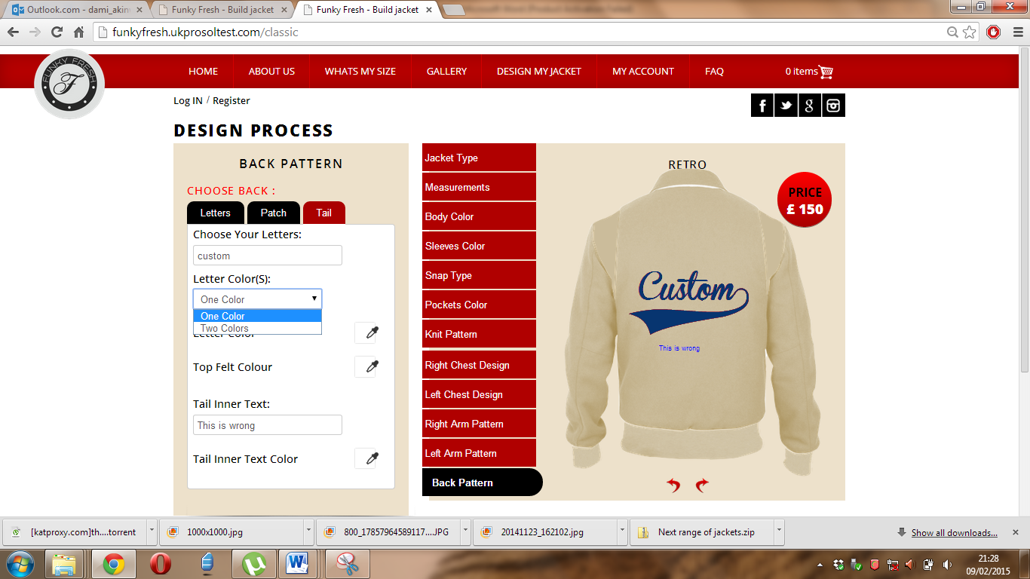

1. You claim to be finished with the transformer jacket but the default knit pattern is still visible when the user selects the transformer to start designing. Please see below:

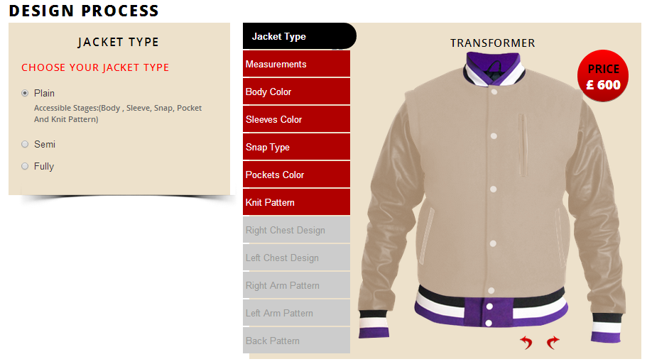

**THE POINTS BELOW ARE THE FEEDBACK FROM THE DOCUMENT TITLED “CHANGES 8.12.14” WHICH YOU STILL HAVE NOT APPLIED TO MY APLETS YET YOU CLAIM TO BE FINISHED!**

* Remove snap option “hidden zip” from all applets but new style applet. Make sure that every applet (EXCEPT THE NEW STYLE APPLET) have the snap options “snap” AND “ZIP”
* Add the knit wear option “single stripe with feathering” to all applets. Also add the 3 stripe knit pattern to all applets.
* In the design stages; right chest, left chest, left arm, right arm and back design, we will now have 3 colours;
  + Letter colour
  + Top felt colour
  + Bottom felt colour



**Please add a third colour around our lettering**

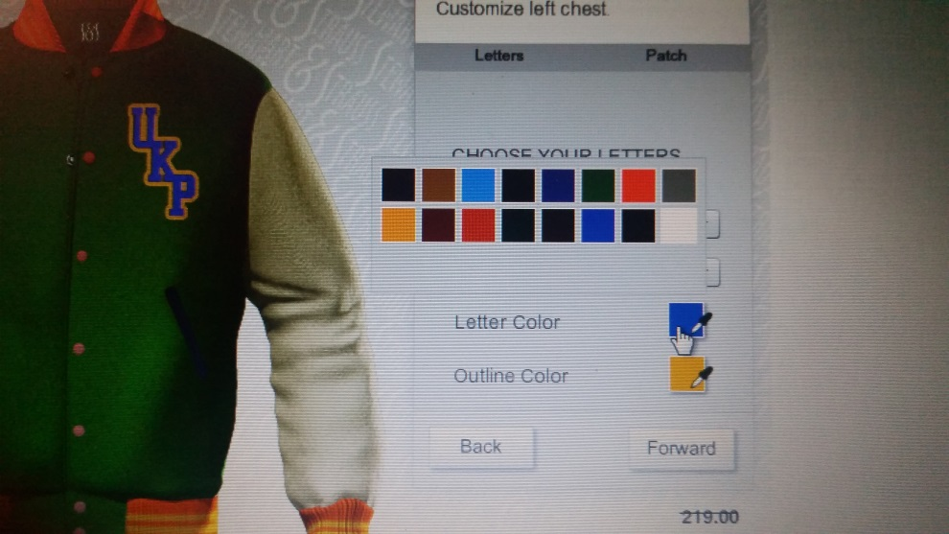

The layout of the options ; letter colour, top felt colour and bottom felt colour should look like this.

**Raglan Jacket**

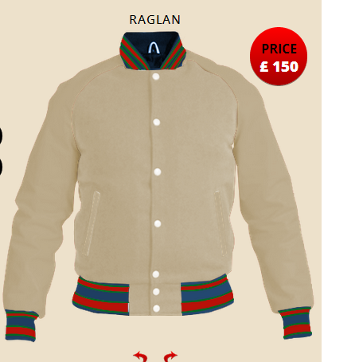The knit pattern is not neat. It should be equal stripes like the knit pattern in the classic jacket applet.

**Retro Jacket**

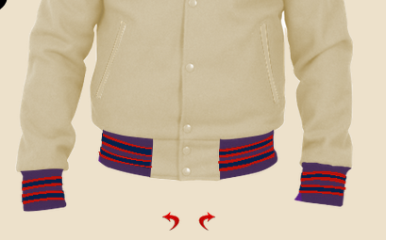The quality of the knit pattern stripes here as well as the feathering is not to the same standard as the classic jacket knit pattern design stage. You should use that design stage as the base mark for the rest of the applets. Our customers will notice the difference in the quality of the knit patterns if they differ from the classic jacket knit pattern design stage.

**New Style**

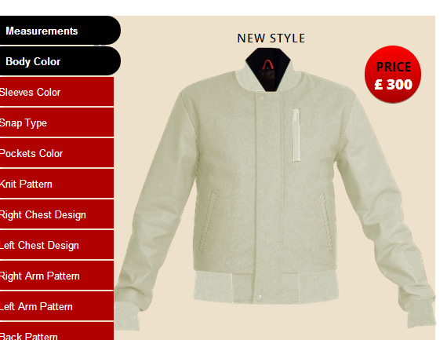

The right cuff is being covered. Please move the jacket to the right so that the cuff is not being covered

* Remove left chest design stage as the zip is there.
* When user selects a pocket colour, the outer section of the left chest zip should also change colour
* 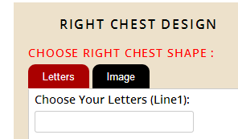

In the right chest option of this applet, there should be 3 options; patch, embroidery and image. For the option “embroidery” the user can write 2 lines of lettering. For the option “patch”, the user should be able to perform the same level of customisation that the “left chest design” stage on other jacket applets can do. i.e. the 1/2/3 letter patches with background colours.